Module 200- Integrated Creativity
Task 1: Research
Harikrishnan Panicker and Deepti Nair:
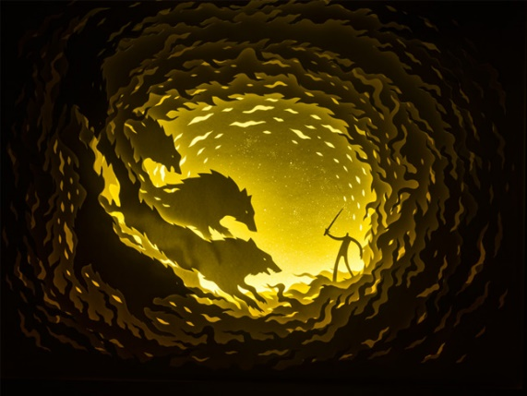
Hari and Deepti work together to create really simple looking, yet impactful paper cut shadow boxes. Hari works as a trained graphic designer and illustrator whereas Deepti’s speciality is cut paper art. This husband-and-wife duo started experimenting with paper cut shadow boxes In 2010 and this is also when they started incorporating LED strip lights within their work.
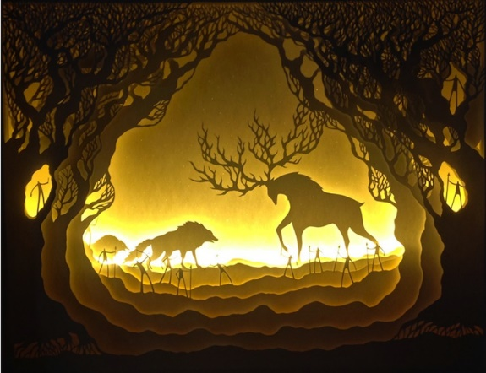
I love how their work looks with and without the lights. The built-up layers of carefully cut paper create so much depth/detail which you wouldn’t think would be possible with just layering paper together. I think the lights make the pieces a lot more enigmatic. It also means that there no need to incorporate colour as the paper has different tones depending on how many layers there is. They had experimented with different colours but liked the simplicity of the white in the end. I think the lights also really help create an energy to the piece, this allows the viewer to feel as if they can feel the movement and predict the storyline/what happens next.
These pieces almost look like they could have been done digitally using different layers and different opacity levels which is why I think these two make a great team. Hari has the skills to create the designs and see what works with his graphics and illustration skills. Planning with this sort of work would be vital as all the layers need to work together. Deepti on the other hand knows how paper as a medium works and how to use it in the way she wants to and this is why together they make a perfect team. This is also because of their close relationship as husband and wife, they already work together in many different within everyday life and this teamwork shows in the outcome of their work too as all pieces are consistently well made and thought out.
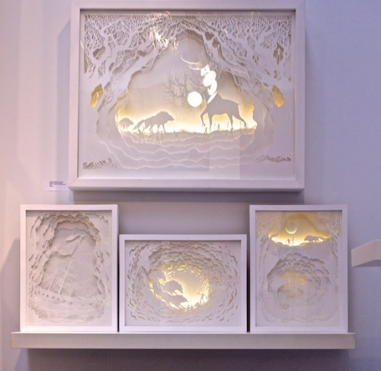
I also really like the way that they talk about paper as a material and the way they don’t see any limitation when using it. They say it “demands attention” and “reflects light, creates depth and illusions in a way that it takes the artist through a journey with limitless possibilities.” Many people would see a lot of these qualities as challenges not positives but it makes me appreciate the work more knowing that they are not only passionate about the art they create but the medium they use. Its shows in their work and how they talk about it that they have taken a lot of time to learn all the possible things that they can do with this one material. Another aspect that is important to them is creating and telling a story which we see by the in depth planning and final outcome of the work.
Overall I really like how well these two artists have come together to create these really well thought out pieces. I like how you can see how much time they spend on the work simply by how many perfectly cut layers it takes to create a paper shadow cut box. I also just think that the minimalism of only using just plain white paper makes the pieces so much better and easier to create the effect they wanted and they do a good at portraying a scene/story.

https://theinspirationgrid.com/paper-cut-artworks-by-hari-deepti/
https://theinspirationgrid.com/paper-cut-artworks-by-hari-deepti/

